**ENERTRACK HUB**

Presented to the Faculty of the Computer and Information Sciences Polytechnic University of the

Philippines - Biñan Campus Biñan, Laguna

In Partial Fulfillment of the Requirements for the Degree Bachelor of Science in Information Technology

By:

Victor Troy J. Avila

Nico S. Ampoloquio

Jimwell L. Rosario

Euryk Matthew C. Dy

Ace V. Tulaña

Happy P. Enciso

Sean Paula G. Estayan

**December 29, 2023**

**INTRODUCTION**

In the rapidly changing energy landscape, staying up to date on monthly rates is not only a matter of financial caution; it is also a critical component of informed decision-making for consumers and businesses alike. Welcome to EnerTrackHub, a dedicated platform aimed at providing a comprehensive understanding of the energy sector through monthly rate tracking and in-depth insights into various aspects of this complex industry.

**Purpose:**

EnerTrackHub has a clear mission: to make energy information accessible and useful for everyone. Our main goal is to give consumers, businesses, and policymakers accurate details about energy prices. By keeping a close eye on monthly rates from major energy companies, our platform wants to help people make smart decisions based on real data. This isn't just about providing numbers – it's about creating a more open and competitive energy market.

We believe that when people have the right information, they can make choices that fit their needs and values. That's why EnerTrackHub goes beyond just tracking rates; we're also here to teach. Our platform is a learning resource, packed with background info to boost everyone's understanding of how energy works. We want to empower users to navigate the energy world with confidence, making choices that are good for their wallets and the planet.

In a nutshell, EnerTrackHub is on a mission to transform the way people interact with energy information. By offering real-time data and fostering energy literacy, we aim to contribute to a more transparent, competitive, and sustainable energy market for everyone.

**Audience:**

Our target audience includes a wide range of energy system stakeholders. This includes the following:

* Consumers: People who want to make informed decisions about their energy providers, comparing rates for the best financial and environmental impact.
* Businesses: Companies that want to manage operational costs, evaluate the sustainability practices of energy providers, and stay on top of industry trends that affect their bottom line.
* Policymakers: Decision-makers who shape energy policies and need comprehensive data and analyses to inform regulatory frameworks that are aligned with broader societal goals.
* Researchers and Students: Academics and students who are interested in the complexities of the energy sector and are looking for reliable data sources and insightful content for their studies.

**Scope:**

The scope of EnerTrackHub is comprehensive, driven by a commitment to delivering real-time insights and fostering energy literacy. A pivotal facet is the Energy Rate Tracker, ensuring accuracy in tracking and updating energy rates. The platform hosts an extensive Educational Repository, curating articles and guides to enhance user understanding. Company Profiles offer transparency on energy firms, detailing history, mission, and sustainability practices. Interactive Tools, including calculators for savings and environmental impact, enrich user decision-making. User Interaction mechanisms, coupled with Responsive Design, optimize engagement across devices. While Scalability and collaboration with stakeholders’ position EnerTrackHub as a user-centric resource within the dynamic energy landscape.

**PROJECT OVERVIEW**

**Project Objectives:**

The project objectives are as follows:

* Energy Rate Tracking: Develop and maintain a dynamic tool that tracks energy rates from leading companies, ensuring users have the most accurate and current information for decision-making.
* Educational Resource: Create an extensive repository of articles, guides, and infographics to enhance energy literacy among users, empowering them to make informed decisions and understand the complexities of the energy sector.
* Company Transparency: Provide detailed profiles of energy companies, including their history, mission, and sustainability practices, enabling users to align their choices with their values and encouraging companies to adopt more sustainable practices.
* Interactive Features: Implement interactive tools for users to calculate potential savings, estimate carbon footprints, and investigate the environmental impact of different energy sources, promoting a holistic understanding of the consequences of energy choices.

**Key Features:**

* Monthly Rate Tracker: Real-time updates on energy rates from leading providers, allowing users to compare and choose the best options for their needs.
* Educational Repository: A comprehensive collection of articles, guides, and infographics covering various energy-related topics to enhance user understanding.
* Company Profiles: Detailed information about energy companies, including their history, mission, and sustainability practices, providing transparency for users.
* Interactive Tools: Calculators for potential savings, carbon footprint estimation, and environmental impact analysis, enabling users to make well-informed decisions.

**Technologies Used:**

(for editing)

* Web Development:
* Frontend: HTML5, CSS3, JavaScript, React.js (for dynamic and responsive user interfaces).
* Backend: Node.js, Express.js (for server-side logic and APIs).
* UI design: Figma (for design prototyping, iterative design, and design version control)
* Database:
* MongoDB or MySQL for storing and retrieving energy rate data, user information, and other relevant content.
* Real-time Updates:
* WebSocket technology to enable real-time updates on energy rates.
* Interactive Features:
* JavaScript libraries or frameworks for creating interactive calculators and visualizations (e.g., D3.js or Chart.js).
* Content Management System (CMS):
* Use of a CMS like WordPress or a custom-built CMS for managing and updating articles, guides, and other content.

**SYSTEM ARCHITECTURE**

EnerTrackHub has been meticulously designed to serve as a comprehensive resource within the ever-changing energy sector. The platform, which uses a layered architecture, prioritizes adaptability and scalability in order to effectively navigate the complex landscape of energy information. The core functionalities are built around a powerful search engine, sophisticated filters, and user-friendly categorizations, all of which are intended to simplify the discovery and comparison of energy-related data.

Users who visit the EnerTrackHub website will find an interface that allows them to quickly access extensive information, real-time rate comparisons, and insightful recommendations. Users encounter an interface designed for ease of use and clarity when researching energy companies, calculating potential savings, or delving into environmental impacts. The layered architecture is driven by a commitment to scalability, performance, and security, ensuring a seamless and secure experience for a growing user base.

In the user component, modules such as the Monthly Rate Tracker enable users to access real-time updates on energy rates, aligning with the project's objective of providing accurate and timely information. The Educational Resource module offers an extensive repository of articles and guides to enhance energy literacy. Company Profiles provide transparency about energy companies, promoting informed decision-making aligned with user values.

The admin component oversees the backend operations, with modules like the Company Database Management ensuring the accuracy and completeness of company profiles. Interactive Features, including calculators and environmental impact analyses, enhance the user experience and contribute to the project's goal of fostering a more informed and sustainable energy market.

EnerTrackHub's system architecture, inspired by a commitment to education and transparency, is a testament to its mission: to revolutionize the energy landscape by providing users with the tools and information needed for informed decision-making.

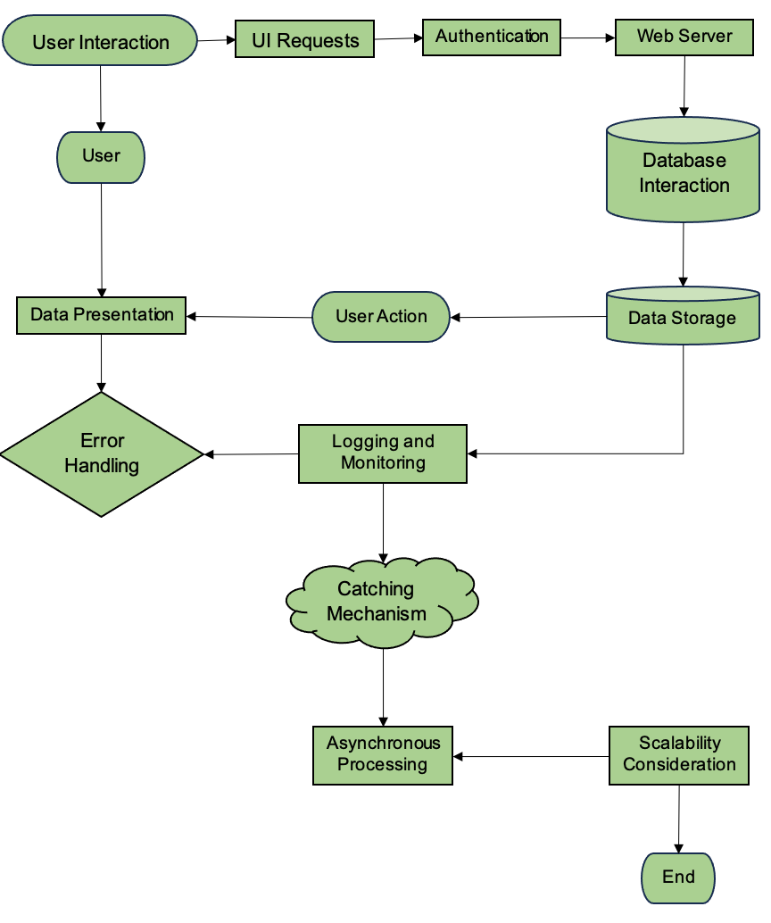

**NAVIGATION MENU AND SITEMAP**

**DESIGN AND LAYOUT**

**Introduction**

The user interface (UI) of the Enertrack Hub is designed to cater to individual eager to delve into the knowledge of energy that provides solution for individual and businesses. Enertrack Hub offers intuitive tools and shared knowledge empowering empowering users to embrace sustainability while efficiently managing their energy usage.

**Key Features:**

1. **Navigation Bar** - A clean and accessible navigation bar at the top provides easy access to core sections such as Home, Portal, Article, Profiles , Contact Us, About Us, Log in.
2. **Home Page** - The home page serves as the central hub for research, offering streamlined access to critical components such as "Explore Us," providing insights into our organizational identity and values. Navigate efficiently to our "Mission" section, delving into the core objectives driving our research endeavors. Access a wealth of informative "Articles" covering a spectrum of research topics, fostering intellectual engagement. The "Information Portal" stands as a comprehensive resource hub, facilitating seamless access to valuable data and insights essential for in-depth research exploration.
3. **Portal Page** - Information Portal is a dedicated platform for rigorous research on gas, oil, and energy exploration. Here, you can access detailed information on the extraction and refinement processes of oil and gas, as well as explore the latest advancements in energy exploration technologies.
4. **Article Page** - Article Page serves as a meticulous resource for research, offering a diverse array of articles centered on oil, gas, energy, and electricity. Explore nuanced discussions on energy production methodologies, technological innovations in the oil and gas sectors, and the evolving landscape of electricity generation.
5. **Profile Page** - The Profile Page is a concise repository of information detailing diverse companies and their respective operations. It offers a streamlined interface for researchers seeking insights into the unique identities and activities of various organizations.
6. **Contact Us Page -** The Contact Us page is a functional platform enabling users to convey messages or address concerns.
7. **About Us Page -** The About Us page introduces the individuals behind the creation of the website, offering users a glimpse into the team responsible for its development.
8. **Log In** - The Log-in Page serves as the secure gateway to personalized access, offering a streamlined entry point for authorized users

**Visual Design:**

1. **Color Scheme**

The color scheme for the Enetrack Hub features a modern and professional palette:

**Primary Background**: White or #FFFFFF

**Smaller Panel**: Shade of Green or #63D168.

**Larger Panel**: Semi transparent shade of green or #63D1683D

1. **Typography**

**Font**: Inter - is a variable font family carefully crafted & designed for computer screens.

**Main Title Font Size**: 120px

**Title of Panel Size**: 55px to 70px

**Content of Each Panel**: 27px

1. **Layout**

The UI design is responsive and allows the user to explore and delve the knowledge of energy that

provide solution and shared knowledge about energy usage.

**CONTENT**

**Text Content**

The Enertrack Hub encourages visitors to learn more about sustainable practices that address energy consumption in order to further their exploration and understanding. Understanding manufacturing and utilizing creativity and easily accessible solutions to shape a greener future. Enertrack Hub talks about a vibrant platform that encourages people and companies to adopt sustainable energy habits. Discover real-world success stories, learn about cutting-edge inventions, and investigate renewable energy sources like wind and solar. As a thorough research gateway, Enertrack Hub provides in-depth analysis of a range of energy-related topics. Examine the oil industry's future, taking a close look at exploration tactics and production trends. Explore renewable energy sources, evaluating their potential and effects on the energy paradigm as a whole. You will also learn about new and developing technologies that can be used to generate power. Multimedia resources are available at the hub, including educational videos with a local and global perspective. For a deeper knowledge, read articles on important subjects including electricity, gas, oil, and more general energy concerns. View profiles of significant businesses influencing the global energy scene, highlighting their contributions and innovations. For scholars looking for a comprehensive grasp of the dynamic and changing energy sector, Enertrack Hub is a great resource.

**Images and Media**

The photo galleries section of the Enertrack Hub captives user to know some information about energy and allowing user to knowing by just seeing the image the topics related when tackling energy. It goes beyond the surface, providing latest innovation highlighting the shaping of greener future and energy and not just for aesthetic purpose yet for functionality of providing information to others

Link: <https://drive.google.com/drive/folders/19BsSxlT8Yb4Wkheza33CUQxEbAddxKg4?usp=sharing>

When it comes to video material, the Enertrack Hub is a dynamic platform that offers a variety of interesting content that explores important oil and energy issues. These films enthrall viewers while simultaneously functioning as instructional resources, offering insightful perspectives into the complex mechanisms of energy-related topics. The films on Enertrack Hub are carefully selected to help visitors understand and navigate the complicated world of energy, whether they are examining the nuances of oil extraction procedures, examining the dynamics of renewable energy sources, or understanding the complexities of electricity generation. The hub seeks to empower users with a deeper understanding of energy-related topics by providing visually engaging and educational material, thereby cultivating an informed and involved community committed to sustainable energy practices.